

Western Australian Certificate of Education
ATAR course examination, 2018

Question/Answer Booklet

12 PHYSICS
Name

Test 5 - Induced EMF

Student Number: In figures

Mark: $\frac{}{\text{64}}$ In words

Time allowed for this paper
Reading time before commencing work: five minutes
Working time for paper: seventy minutes

Materials required/recommended for this paper

To be provided by the supervisor
This Question/Answer Booklet
Formulae and Data Booklet

To be provided by the candidate
Standard items: pens, (blue/black preferred), pencils (including coloured), sharpener, correction fluid/tape, eraser, ruler, highlighters
Special items: non-programmable calculators satisfying the conditions set by the School Curriculum and Standards Authority for this course

Important note to candidates
No other items may be taken into the examination room. It is your responsibility to ensure that you do not have any unauthorised notes or other items of a non-personal nature in the examination room. If you have any unauthorised material with you, hand it to the supervisor before reading any further.

Structure of this paper

Section | Number of questions available | Number of questions to be answered | Suggested working time  (minutes) | Marks available | Percentage of exam
Section One:  Short Answers | - | - | -
Section Two:  Problem-solving | 12 | 12 | 70 | 64 | 100
Section Three:  Comprehension | - | - | - | - | -
 |  |  |  | Total | 100

Instructions to candidates

1. The rules for the conduct of examinations at Holy Cross College are detailed in the College Examination Policy. Sitting this examination implies that you agree to abide by these rules.

2. Write your answers in this Question/Answer Booklet.

3. Working or reasoning should be clearly shown when calculating or estimating answers.

4. You must be careful to confine your responses to the specific questions asked and to follow any instructions that are specific to a particular question.

5. Spare pages are included at the end of this booklet. They can be used for planning your
responses and/or as additional space if required to continue an answer.

• Planning: If you use the spare pages for planning, indicate this clearly at the top of the page.
• Continuing an answer: If you need to use the space to continue an answer, indicate in the original answer space where the answer is continued, i.e. give the page number. Fill in the number of the question(s) that you are continuing to answer at the top of the page.

6. Answers to questions involving calculations should be evaluated and given in decimal
form. It is suggested that you quote all answers to three significant figures, with the
exception of questions for which estimates are required. Despite an incorrect final result, credit may be obtained for method and working, providing these are clearly and legibly set out.

7. Questions containing the instruction "estimate" may give insufficient numerical data for their solution. Students should provide appropriate figures to enable an approximate solution to be obtained. Give final answers to a maximum of two significant figures and include appropriate units where applicable.

8. Note that when an answer is a vector quantity, it must be given with magnitude and direction.

9. In all calculations, units must be consistent throughout your working.
The first 4 questions are multiple choice (1 mark each). Circle the correct answer.

1. Four conductors of different lengths are moved through a uniform magnetic field at the
same speed. Which conductor will induce the greatest EMF?

(a) 1 (b) 2 (c) 3 (d) 4

2. A step-down transformer has a 500-turn primary that operates at 120 V ac.
Which of the following sets of conditions best describes the number of secondary turns
and secondary voltage of this transformer?

3. In which of the following diagrams is the secondary current greater than the primary
current?

4. In which of the following situations would the greatest EMF be induced in the coil?
All changes occur in the same time interval.

5. An aeroplane with a wingspan of 10.0 m is flying horizontally at a velocity of
2.00 x 10² ms⁻¹. In the region the plane is flying, the Earth’s magnetic field is 2.00 x 10⁻⁴ T downwards at an angle of 60.0 º to the horizontal.

Indicate clearly the polarity induced and determine the magnitude of EMF induced across the wingtips of the plane? (5 marks)

6. An ideal transformer for a toy train set plugs into the 240 V mains supply and changes it
to 12.0 V. The toy train draws 0.720 A from the transformer.

(a) If the primary is found to consist of 360 turns of wire, how many turns will the secondary have? (2 marks)

(b) Determine the current in the primary section of the transformer. (2 marks)

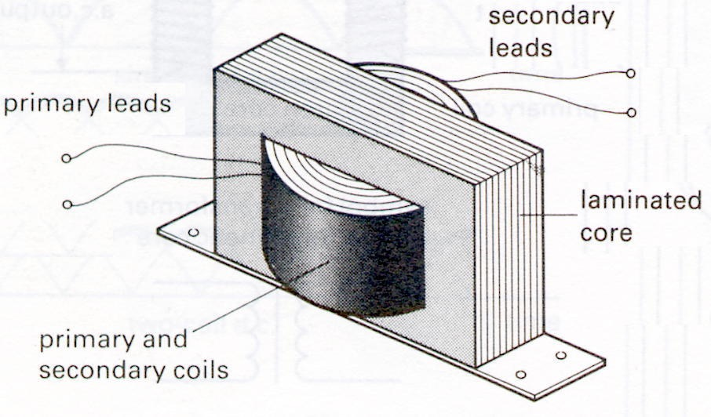

(c) Carefully explain why the core of a transformer consists of many thin laminated sheets bonded together instead of a single solid soft iron cast. (2 marks)

7. The diagram shows a wind turbine that runs a 1.50 x 10² kW generator with an output voltage of 1.00 kV. The voltage is increased by transformer T₁ to 10.0 kV for transmission to a town 5.00 km away through power lines with a total resistance of 2.00 Ω. Another transformer (T₂) at the town reduces the voltage to 2.50 x 10² V. Assume that the transformers are ‘ideal’.

When the system is running at full power:

(a) what is the current in the power line? (1 mark)

(b) what is the voltage drop along the power line and the voltage at the input to the town transformer? (2 marks)

(c) how much power is lost in the power line? Is this a significant problem? (2 marks)

8. (a) Two coils are placed side-by-side so that the magnetic field produced by one of the coils passes through the other. Indicate the direction of the induced current through the galvanometer G in the secondary coil, if any.

(i) If the switch in the primary coil has been closed for 30 seconds. (1 mark)

(ii) If the switch in the primary coil is then opened. (1 mark)

(b) The figure shows the magnetic field seen when facing a current loop in the plane of the page.

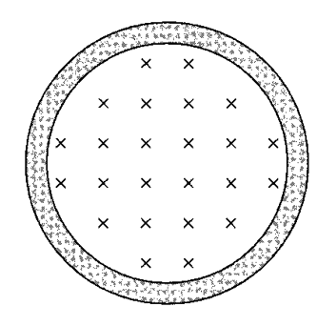

(i) On the figure above, show the direction of the current in the loop. (1 mark)

(ii) Is the north pole of this loop at the upper surface of the page or the lower surface of the page? Explain. (2 marks)

(c) Consider the not-to-scale diagram to the right. A wire, carrying a clockwise current of 20.0 A is looped back on itself with 2.00 mm maximum between the wires.
1 mm
X
2 mm

What is the magnetic field strength at point X, which is 1.00 mm to the right of the edge of the wire loop? (4 marks)

9. Three rings are dropped at the same time over identical magnets as shown below.

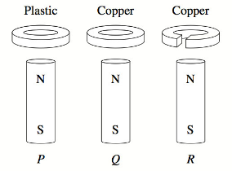

(a) Which of the following describes the order in which the rings reach the bottom of the magnets? Circle your answer. (2 marks)

(i) They arrive in the order P, Q and R.
(ii) They arrive in the order P, R and Q.
(iii) Rings P and R arrive simultaneously, followed by Q.
(iv) Rings Q and R arrive simultaneously, followed by P.

(b) Justify your answer using relevant Physics laws. (3 marks)

10. The diagram below shows a simple AC electric generator. [15 marks]

As the loop is rotated in the magnetic field,
an EMF is induced. The graph below shows
how the induced EMF varies with time.

(a) Which point, A or B, in the graph could
possibly correspond to the point of rotation
shown in the diagram right?

_______ (1 mark)

A
B

(b) With what frequency is the generator turning? (1 mark)

(c) In a typical single-phase AC generator, the maximum EMF_{rms} induced is 350 V and its
rotating coil consists of 500 turns. Find the magnetic flux (φ) in the generator.
(4 marks)

(d) In a commercial power station, the generators have electromagnets to provide the
magnetic field. What are some of the advantages and disadvantages of this design principle? (3 marks)

At Pinjar power station, the electricity is produced at 350 V and then stepped up to 132 kV before it is transmitted to the city.

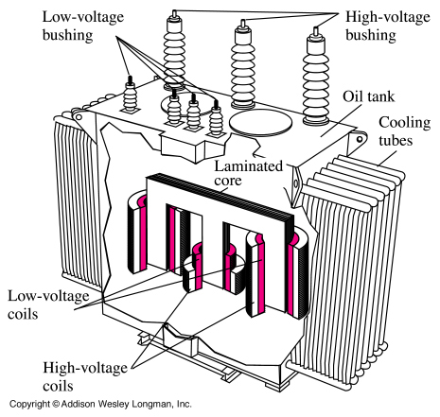
(e) The transformer has an extensive cooling system
to remove the large quantities of heat produced.
Why does the transformer produce this heat?
(2 marks)

(f) Why is it necessary to step up the voltage before it is transmitted? (2 marks)

(g) Why is electrical energy transmitted from generator to consumers using an alternating
current? (2 marks)

11. During the Second World War, it was common to guard harbours using a coil of very large area

laid across the entrance to the harbour.

This device was intended to detect the presence of a submarine by the voltage induced as the submarine passed over the harbour loop.

(a) Carefully explain how such a voltage might be induced. (3 marks)

(b) If, as a submarine passes, the flux passing perpendicularly through a 50-turn loop
changes at a rate of 8.00 x 10⁻³ weber per second, what EMF would be induced in
the loop? (3u marks)

(c) At the site of this harbour, natural variations in the vertical component of the Earth's
magnetic field might occur at the rate of 3.00 x 10⁻¹⁰ tesla per second.

What is the maximum area the harbour loop must have if the naturally induced voltage is to remain below 1.00% of that induced by the submarine? (3 marks)

12. A rectangular conducting loop of mass 4.50 x 10⁻² kg and resistance 1.50 Ω is dropped in
the direction shown through a uniform horizontal magnetic field of 1.80 T.

Determine the speed this loop will be falling through the magnetic field when it stops accelerating? (7 marks)

END OF TEST

